Effects Operations Overview — Lesson Plan
Classification: UNCLASSIFIED

1. Administrative and metadata

1.1 Lesson title
Effects Operations Overview

1.2 Module length
60 minutes (1 hours)
Schedule slot is 60 minutes. Content-guide ~75 minutes is the longer opening narrative.

1.3 Terminal and enabling learning objectives
- TLO-1: At the end of the Counterstrike Operator Course, students will possess the ability to conduct military tactical planning in the context of DCO-RA
- TLO-3: At the end of the Counterstrike Operator Course, students will be able deny adversary ability to accomplish their mission in cyberspace.
- ELO-34: Identify and Map military tactical tasks to MITRE ATT&CK impact techniques.
- ELO-55: Analyze the relationship between military tactical tasks and MITRE ATT&CK impact techniques.
- ELO-56: Select appropriate MITRE ATT&CK impact techniques to accomplish military tactical tasks.
- ELO-57: Sequence MITRE ATT&CK impact techniques to effectively accomplish military tactical tasks.
- ELO-59: Create a comprehensive plan that integrates MITRE ATT&CK impact techniques to support military tactical tasks.
- ELO-60: Identify impact techniques from the MITRE attack frameworks (data destruction, data encrypted for impact, data manipulation, disk wipe, service stop, system shutdown/reboot).
- ELO-81: Communicate planned effects using terminology from US joint military doctrine.

1.4 Prerequisites
- B04.M04: Offensive Tool Testing

2. Personnel, range, and environment

2.1 Instructor and cadre
- 1 × instructor (required)
- 0 × range_engineer (not_applicable: Lecture Module; no range engineer required)
- 0 × auditor (not_applicable: Not used by this course)
- 0 × oversight_officer (not_applicable: Not used by this course)

2.2 Materials and resources
Instructor resources and pre-class preparation
- Classroom projector and screen; whiteboard for the opening contract
- Parent or sibling briefs listed in this Module folder
- Live tabs and references already named in this file's header
- Do not project flags, tokens, or answer-key values
Student resources and environment
- Student brief, student guide, or homework file in this Module folder when present
- Assigned range, workstation, or lab stack named in the student-facing file
- No extra kit beyond what the student-facing file already lists

3. Assessment and evaluation
ELO | Method | Related Module | Criteria
ELO-34 | in-class Q&A | — | In-class questions and check on learning in the content guide.
ELO-55 | in-class Q&A | — | In-class questions and check on learning in the content guide.
ELO-56 | in-class Q&A | — | In-class questions and check on learning in the content guide.
ELO-57 | in-class Q&A | — | In-class questions and check on learning in the content guide.
ELO-59 | in-class Q&A | — | In-class questions and check on learning in the content guide.
ELO-60 | in-class Q&A | — | In-class questions and check on learning in the content guide.
ELO-81 | in-class Q&A | — | In-class questions and check on learning in the content guide.

4. Instructional delivery

4.1 Opening, attention grabber, and motivator

Option 1 (Interactive / Whiteboard / Kinesthetic)
- Say: "You will be issued a live harvest collection cell. Access is the price of admission. This hour is about the effect you produce once you are there: break collection, then poison it, then hand it off."
- Do: Put the lesson contract on the board. Keep products from the prerequisite Module available.
- Ask (Q): From planning, what is the center of gravity of the APT we studied?
- Expected Response (A): Facilitation. Use the Say/Do already on this row; do not force a single keyed answer.

Option 2 (Digital Slide / Virtual / Slide Deck)
- Say: "You will be issued a live harvest collection cell. Access is the price of admission. This hour is about the effect you produce once you are there: break collection, then poison it, then hand it off."
- Show: The title slide and lesson objectives.
- Do: Confirm stations can open the required tool or file before the first teaching row.
- Ask (Q): From planning, what is the center of gravity of the APT we studied?
- Expected Response (A): Facilitation. Use the Say/Do already on this row; do not force a single keyed answer.

4.2 Side-by-side table of instruction
Visual / Slide Asset | Instructional Delivery & Instructor Notes
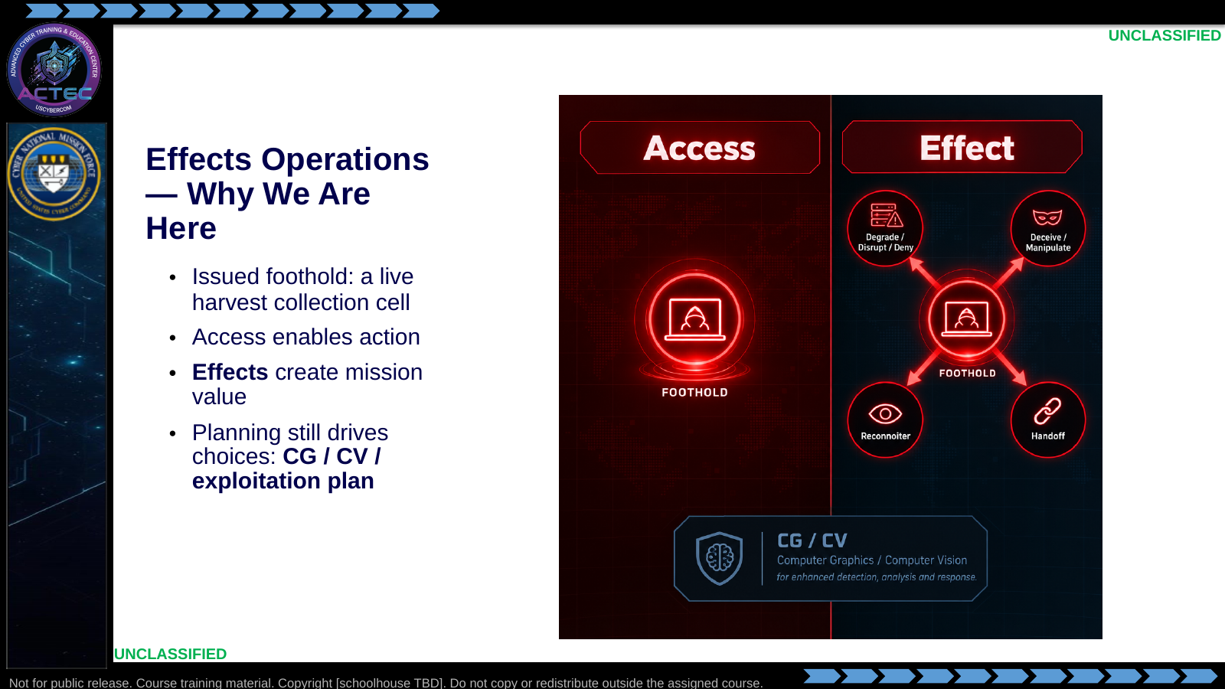  Slide 1: Effects Operations — Why We Are Here  Duration: 3 min | Say: - "You will be issued a live harvest collection cell."  - "That access is the price of admission."  - "This hour asks the next question: now that you are there, what do you do?"  - "Access matters when it produces a deliberate, bounded effect."  - "Every effect still has to support the CG/CV logic."  - "First two days: deliberate effects."  - "Last three days: doing this with SI help, and recognizing adversary SI use."  Show: - Point from "Access" to "Effect."  - Point at the CG/CV callout.  Do: - Ask: "From planning, what is the center of gravity of the APT we studied?"  - Take one answer.  - Ask: "And what is a critical vulnerability against that CG?"  - Capture both on the whiteboard as the running example.  Ask (Q): From planning, what is the center of gravity of the APT we studied?  Expected Response (A): Facilitation. Use the Say/Do already on this row; do not force a single keyed answer.
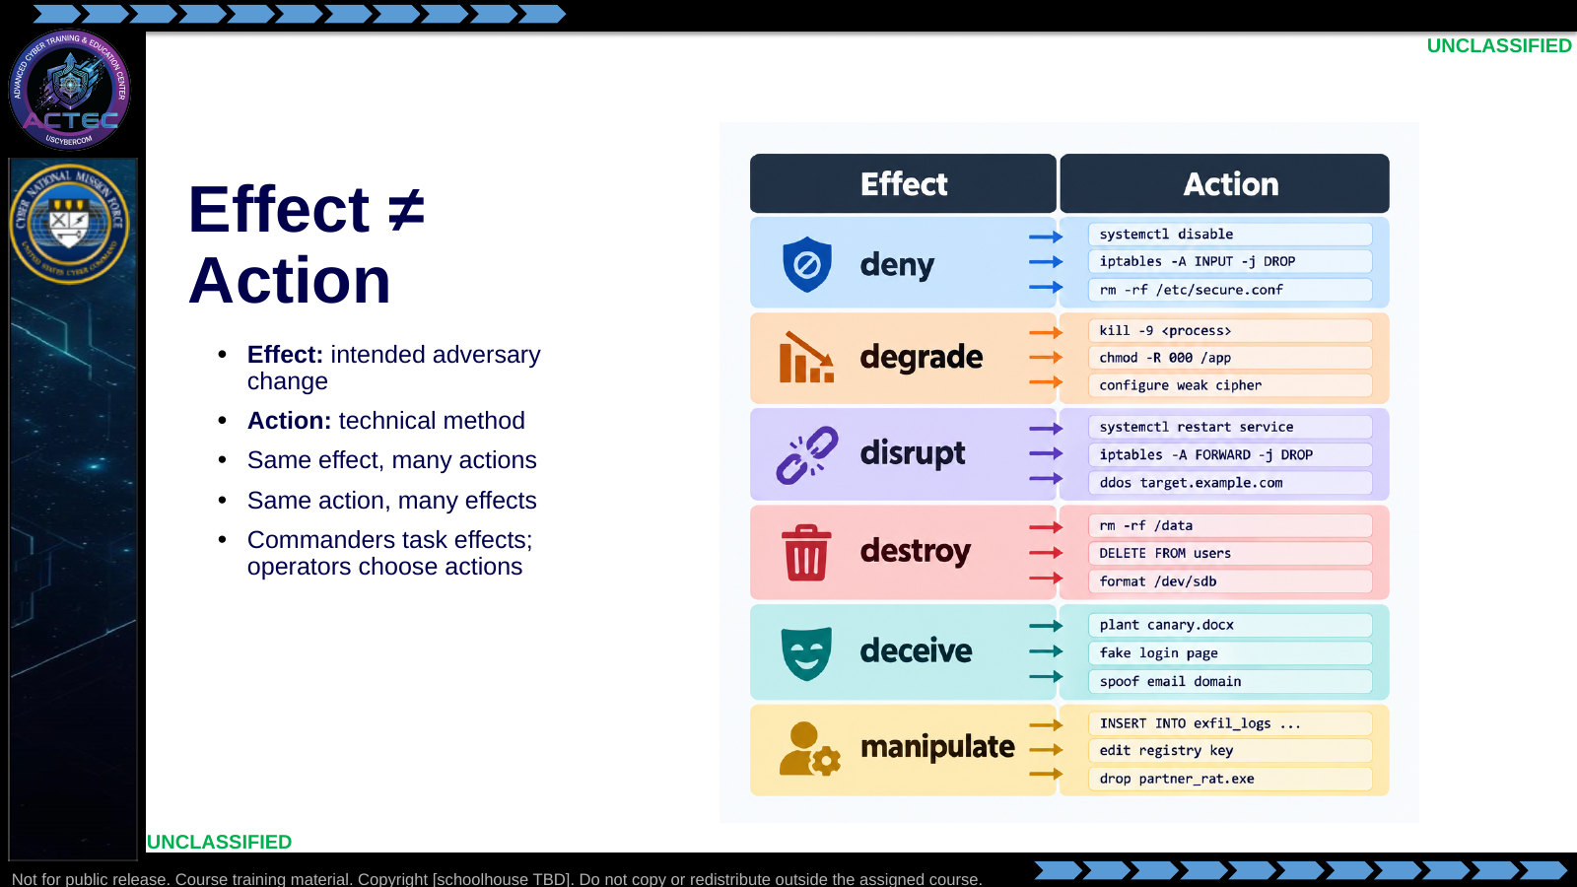  Slide 2: Effect ≠ Action  Duration: 3 min | Say: - "Effect versus action keeps you out of trouble."  - "Commander says: degrade their collection."  - "That is an effect."  - "You choose the action: stop a service, poison a database, corrupt logs."  - "Choice depends on assessment, risk, access reliability, team skill, and partner need."  - "Do not report an effect you did not actually achieve."  Show: - Point to the effect column.  - Point to the action column.  - Linger on the multi-to-multi arrows.  Do: - Ask: "Name an action you took on a prior on-target host."  - Ask: "What effect, if any, did it produce?"  - Take two answers.  - Correct effect/action conflation.  Ask (Q): Name an action you took on a prior on-target host.  Expected Response (A): Facilitation. Use the Say/Do already on this row; do not force a single keyed answer.
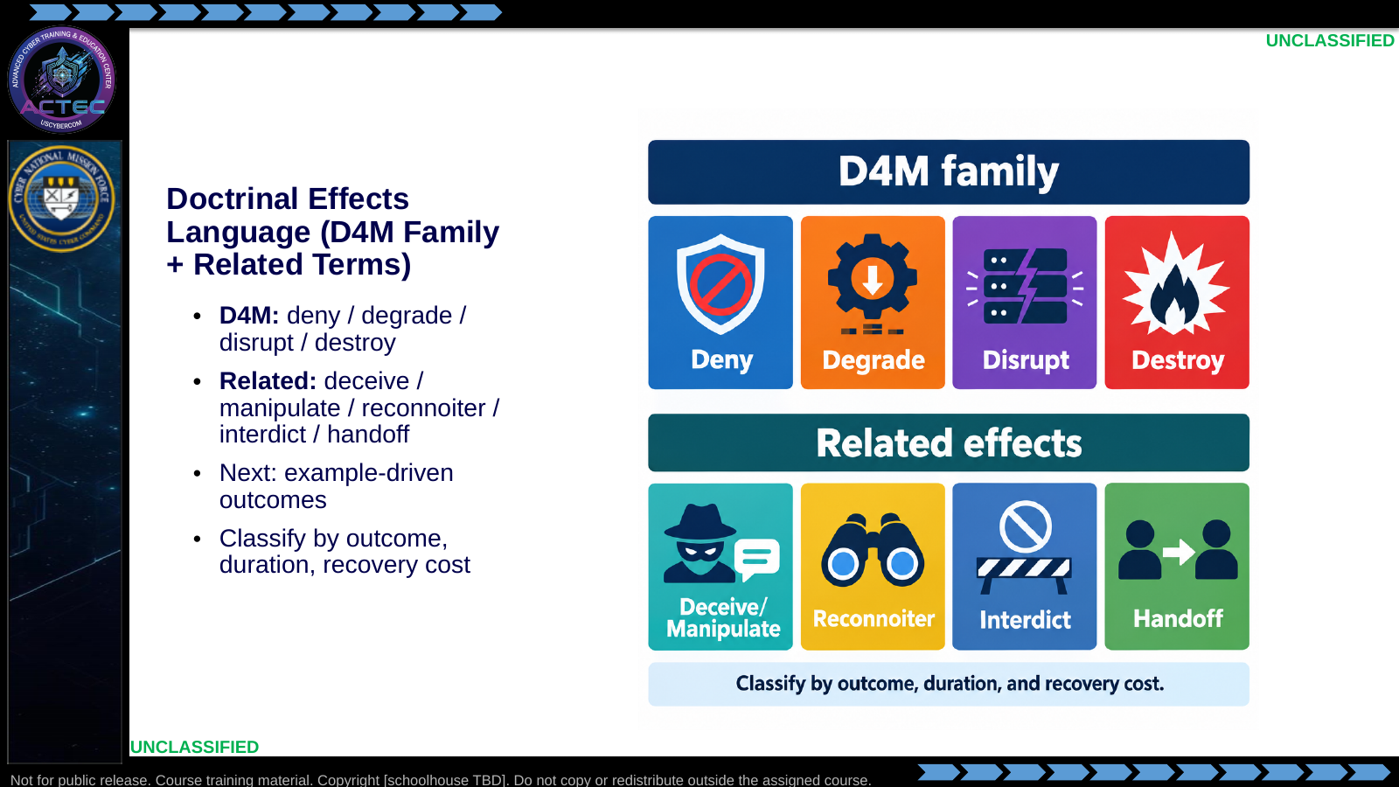  Slide 3: Doctrinal Effects Language (D4M Family + Related Terms)  Duration: 3 min | Say: - "This is planning language, not a new dictionary."  - "D4M verbs describe what you want done to an adversary capability."  - "Related terms cover decision-cycle attack, intelligence collection, pathway denial, and partner transition."  - "Classification is not the command you typed."  - "Classification is what changed, how long it lasts, and how hard recovery is."  - "The next slides stay concrete and example-driven."  Show: - Walk the D4M row left to right.  - Walk the related-effects row left to right.  - Point at the footer classification line.  Do: - Tell students: "For every example, ask what the adversary lost, kept, missed, or misunderstood."  - Tell students: "Also ask what you must check before touching the keyboard."  Ask (Q): What is the operational takeaway from this row?  Expected Response (A): Facilitation. Restate the Say/Do in operator terms. Do not invent a new teaching point.
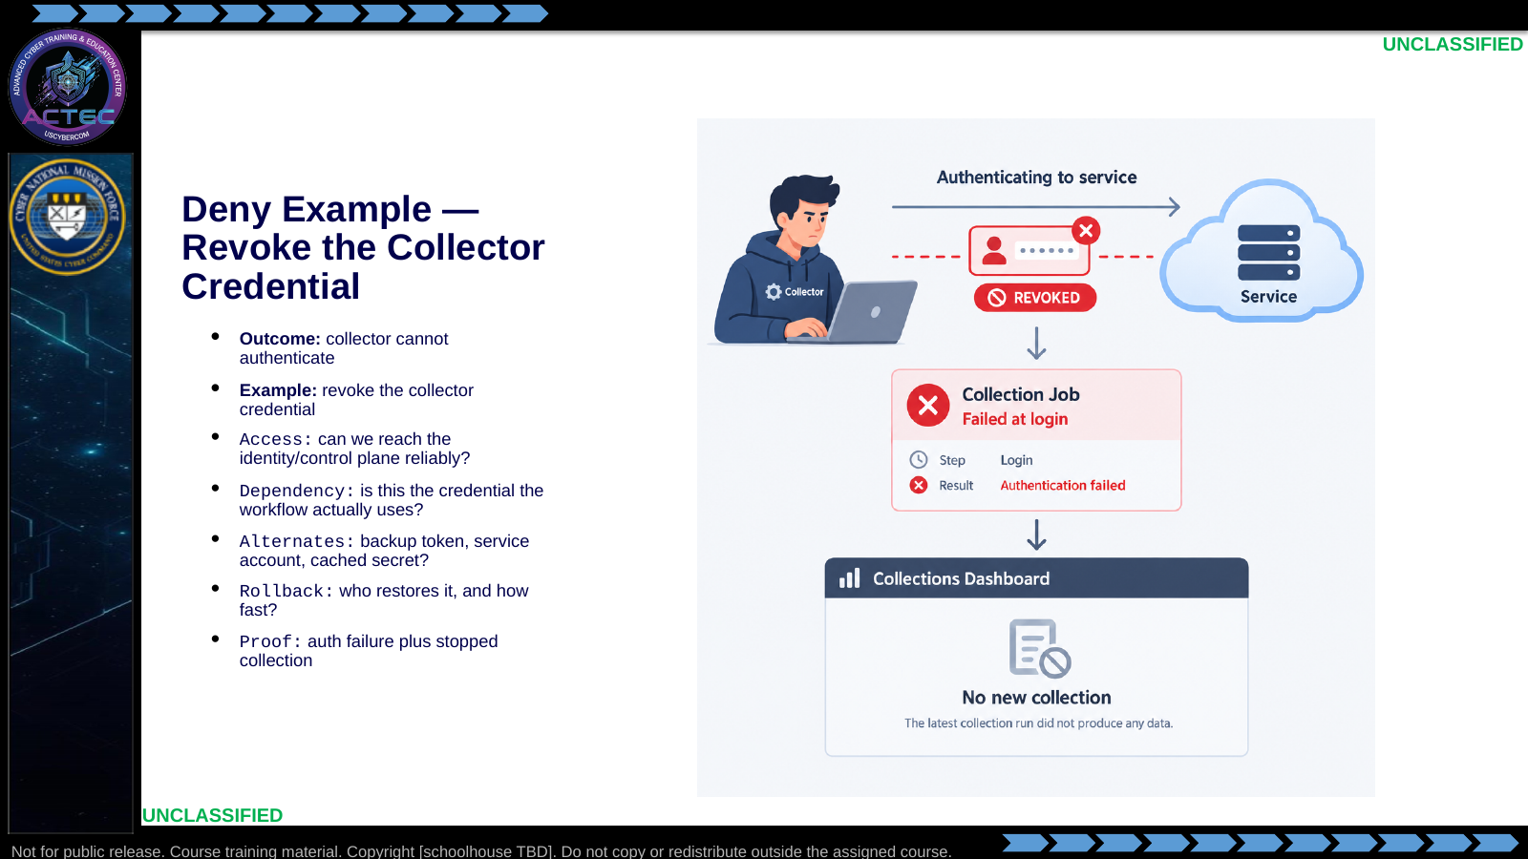  Slide 4: Deny Example — Revoke the Collector Credential  Duration: 3 min | Say: - "Deny is a hard stop."  - "The adversary still wants to run the capability, but cannot."  - "Scenario: the collector polls a staging API with one service credential."  - "That credential is the dependency that lets collection run."  - "Action: disable, revoke, or rotate that credential so the collector cannot log in."  - "Do not assume the credential matters; prove the workflow uses it."  - "Check for alternate credentials before calling this denial."  - "Evidence should show authentication failure and stopped collection."  - "If a backup token keeps the workflow alive, you did not deny it."  Show: - Point to the revoked credential.  - Point to the failed login.  - Point to the missing downstream collection.  Do: - Ask: "What would prove this credential is the real dependency?"  - Ask: "What alternate path would defeat this denial?"  Ask (Q): What would prove this credential is the real dependency?  Expected Response (A): Facilitation. Use the Say/Do already on this row; do not force a single keyed answer.
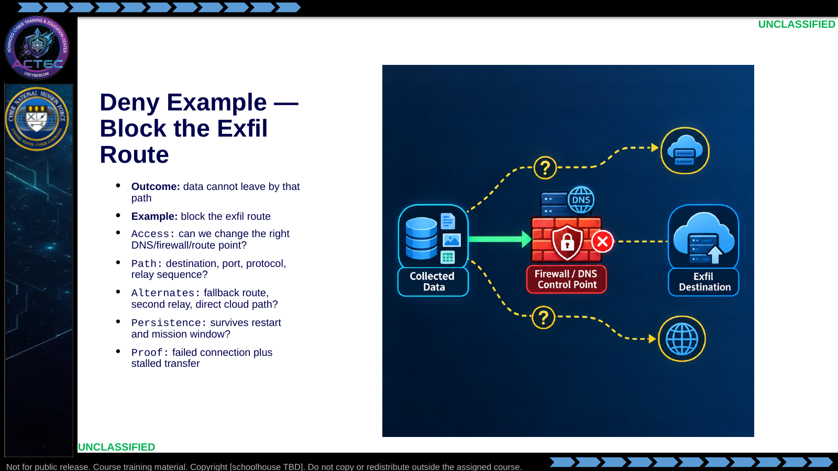  Slide 5: Deny Example — Block the Exfil Route  Duration: 3 min | Say: - "This is still deny because the selected path becomes unusable."  - "The target is network reachability, not the local tool."  - "Scenario: collection bundles leave through a relay path to a known reporting destination."  - "That path depends on a DNS, firewall, proxy, or route control point."  - "Action: block or sinkhole the selected route so bundles cannot reach the destination."  - "Students must identify the actual route before changing controls."  - "Check for fallbacks, second relays, or direct cloud paths."  - "Rule persistence matters if the mission window spans restarts."  - "Evidence should show connection failure and no successful transfer."  - "If traffic simply moves to another path, denial failed."  Show: - Trace the normal route.  - Point to the block point.  - Point to alternate-route checks.  Do: - Ask: "What makes this route the right control point?"  - Ask: "What evidence separates route denial from a local tool crash?"  Ask (Q): What makes this route the right control point?  Expected Response (A): Facilitation. Use the Say/Do already on this row; do not force a single keyed answer.
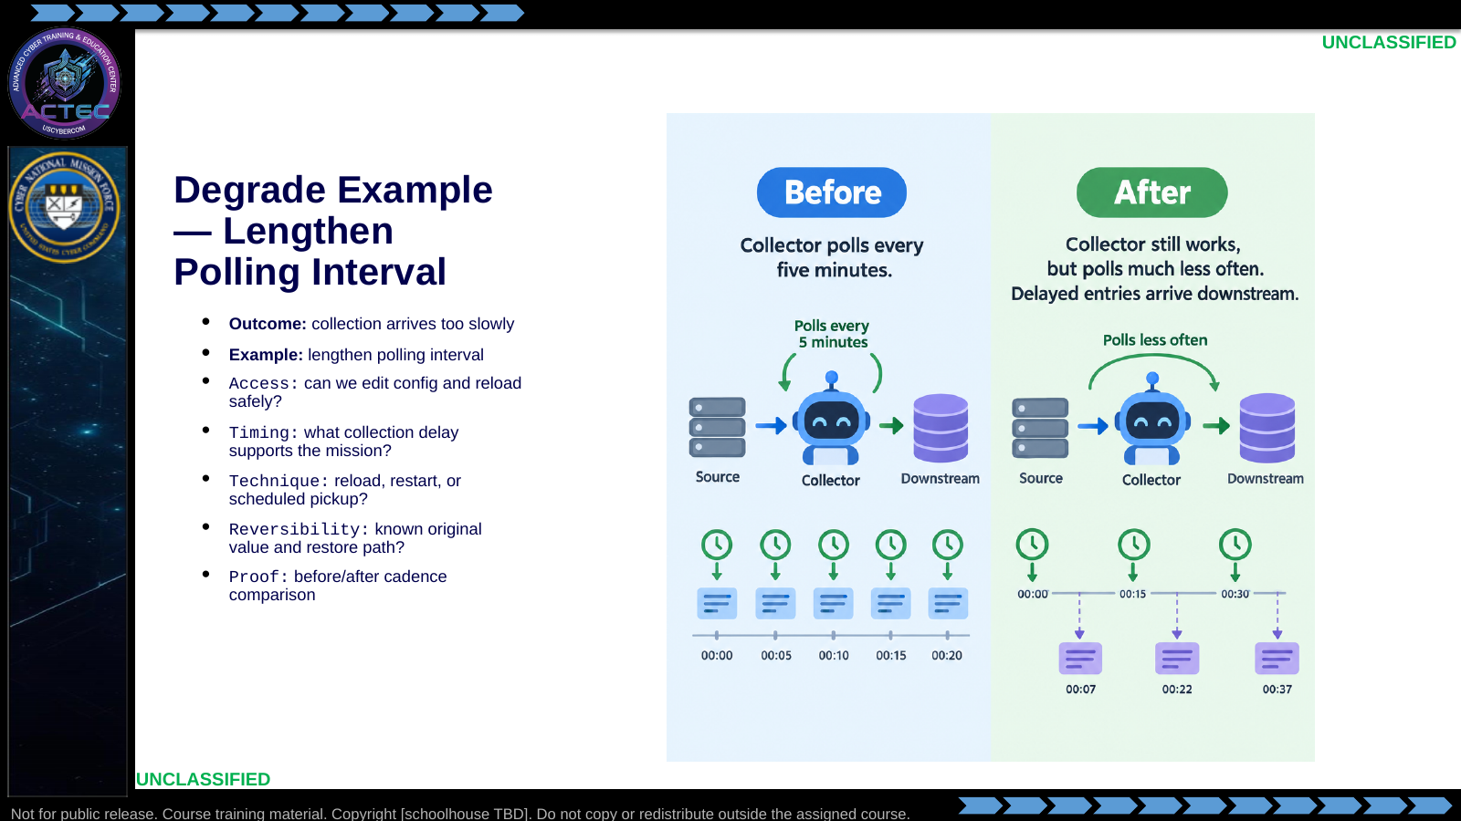  Slide 6: Degrade Example — Lengthen Polling Interval  Duration: 3 min | Say: - "Degrade keeps the capability alive but worse."  - "Here, the product is less timely."  - "Scenario: a collector polls endpoints on a short interval and forwards results downstream."  - "The adversary still gets data because the pipeline remains alive."  - "Action: change the polling schedule so collection happens much less often."  - "Do not pick an interval at random."  - "Tie the delay to the mission window."  - "Know whether the config needs reload or restart."  - "Preserve the original value for rollback."  - "Evidence is a before/after cadence comparison."  Show: - Compare normal cadence to delayed cadence.  - Point out that collection still occurs.  Do: - Ask: "When does slow become operationally useful?"  - Ask: "When would this accidentally become deny?"  Ask (Q): When does slow become operationally useful?  Expected Response (A): Facilitation. Use the Say/Do already on this row; do not force a single keyed answer.
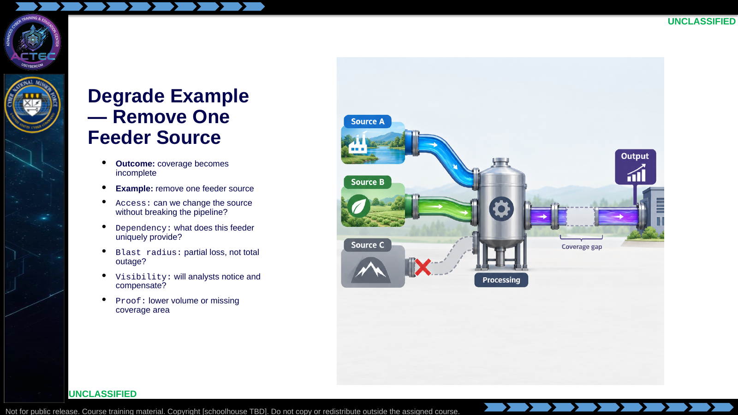  Slide 7: Degrade Example — Remove One Feeder Source  Duration: 3 min | Say: - "This degradation reduces coverage rather than timing."  - "The pipeline still runs."  - "The product is less complete."  - "Scenario: a redirector receives feeds from multiple implants."  - "Those feeds are consolidated, parsed, and forwarded to a backend database."  - "Action: remove or disable one feeder source while leaving the rest of the pipeline intact."  - "Students must know what the feeder uniquely contributes."  - "The goal is partial loss, not total outage."  - "Analyst visibility matters; obvious loss may trigger fast repair."  - "Evidence is lower volume or a missing coverage slice."  Show: - Point to the removed feeder.  - Point to the remaining pipeline.  - Point to the output gap.  Do: - Ask: "What would make this too obvious?"  - Ask: "What evidence proves degradation instead of denial?"  Ask (Q): What would make this too obvious?  Expected Response (A): Facilitation. Use the Say/Do already on this row; do not force a single keyed answer.
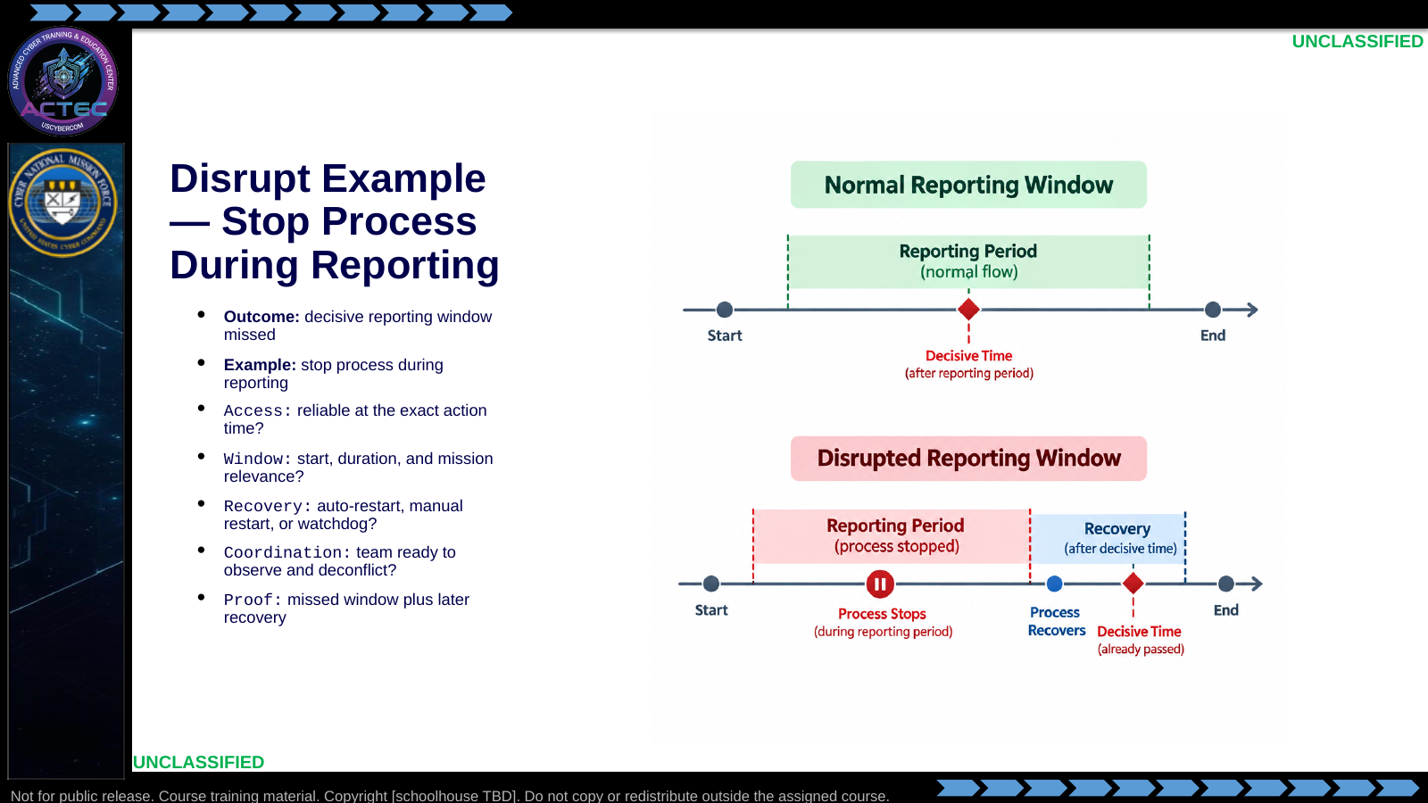  Slide 8: Disrupt Example — Stop Process During Reporting  Duration: 3 min | Say: - "Disrupt breaks rhythm."  - "The capability may come back."  - "The problem is that it comes back too late."  - "Scenario: a collection process has one reporting window that matters to the mission."  - "If that window is missed, later recovery does not undo the disruption."  - "Action: stop the process during the reporting window and allow recovery afterward."  - "Timing is the center of this example."  - "Students need the real reporting window, not a guess."  - "Watchdog or auto-restart behavior changes the effect."  - "Evidence is the missed window plus later recovery."  Show: - Point to the reporting window.  - Point to the outage inside the window.  - Point to recovery after the window.  Do: - Ask: "If it restarts after ten minutes but the window was five, what effect is that?"  - Ask: "What evidence would you capture?"  Ask (Q): If it restarts after ten minutes but the window was five, what effect is that?  Expected Response (A): Facilitation. Use the Say/Do already on this row; do not force a single keyed answer.
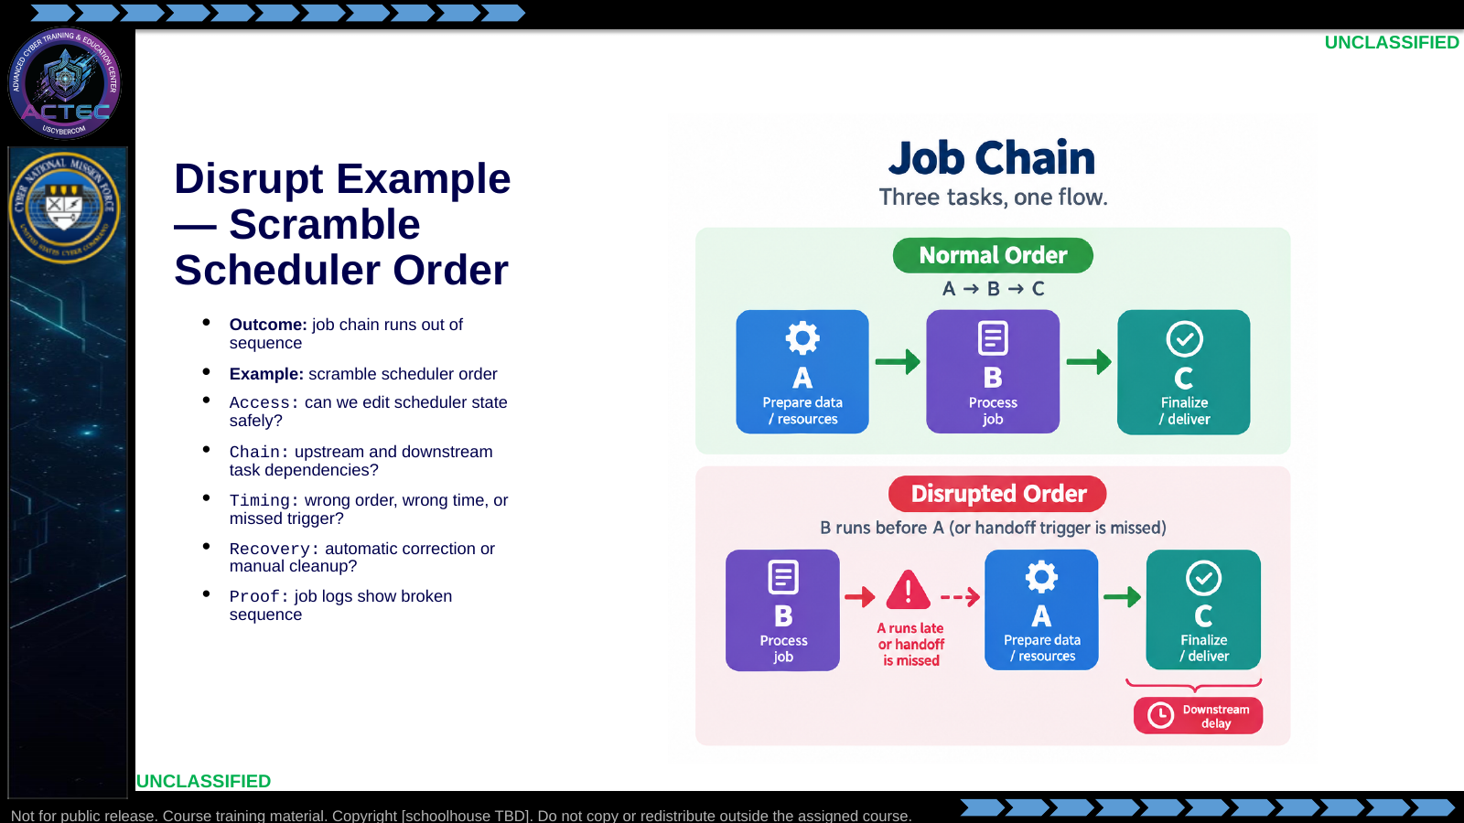  Slide 9: Disrupt Example — Scramble Scheduler Order  Duration: 3 min | Say: - "This disrupts coordination, not the whole capability."  - "The tasks may all still exist."  - "The sequence no longer supports the workflow."  - "Scenario: scheduled jobs collect, parse, stage, and forward data in a fixed order."  - "Downstream jobs depend on upstream output being ready at the right time."  - "Action: change schedule order or trigger timing so jobs run before prerequisites exist."  - "Students must map dependencies before changing schedule state."  - "Know whether the system self-corrects."  - "Manual cleanup means added adversary burden."  - "Evidence comes from job logs and delayed downstream action."  Show: - Trace the normal order.  - Trace the scrambled order.  - Point to the broken handoff.  Do: - Ask: "Which dependency must students prove first?"  - Ask: "When would this drift into denial?"  Ask (Q): Which dependency must students prove first?  Expected Response (A): Facilitation. Use the Say/Do already on this row; do not force a single keyed answer.
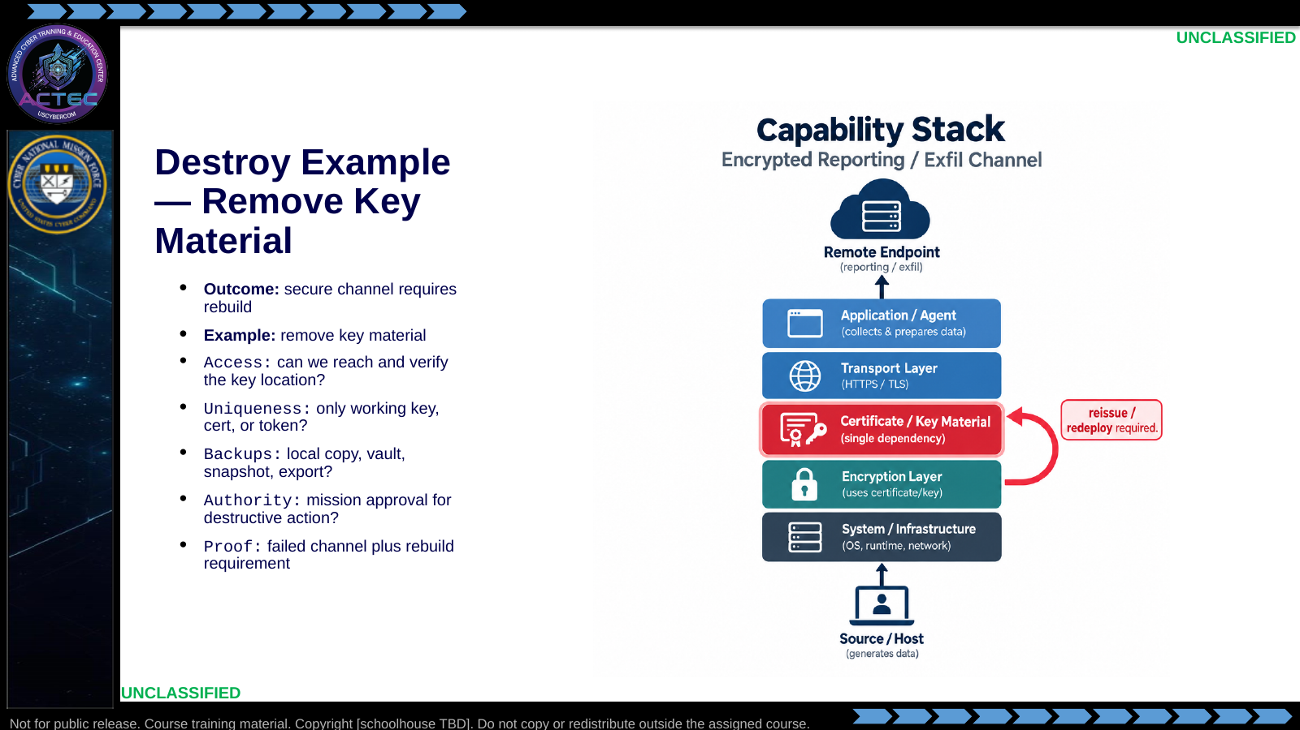  Slide 10: Destroy Example — Remove Key Material  Duration: 3 min | Say: - "Destroy means recovery is hard."  - "Here, the destroyed dependency is key material."  - "Scenario: the reporting channel depends on one deployed certificate, private key, or token."  - "Without that material, the adversary must reissue and redeploy before the channel works."  - "Action: remove the required key material and any immediately usable local copy."  - "A deleted key only matters if it is unique and required."  - "Backups can turn destroy into short disruption."  - "This requires explicit mission approval."  - "Evidence must show failed channel operation and rebuild burden."  - "Do not call it destroy just because a file was deleted."  Show: - Point to the key dependency.  - Point to backup checks.  - Point to rebuild requirement.  Do: - Ask: "What makes this destructive instead of disruptive?"  - Ask: "What backup evidence would change your classification?"  Ask (Q): What makes this destructive instead of disruptive?  Expected Response (A): Facilitation. Use the Say/Do already on this row; do not force a single keyed answer.
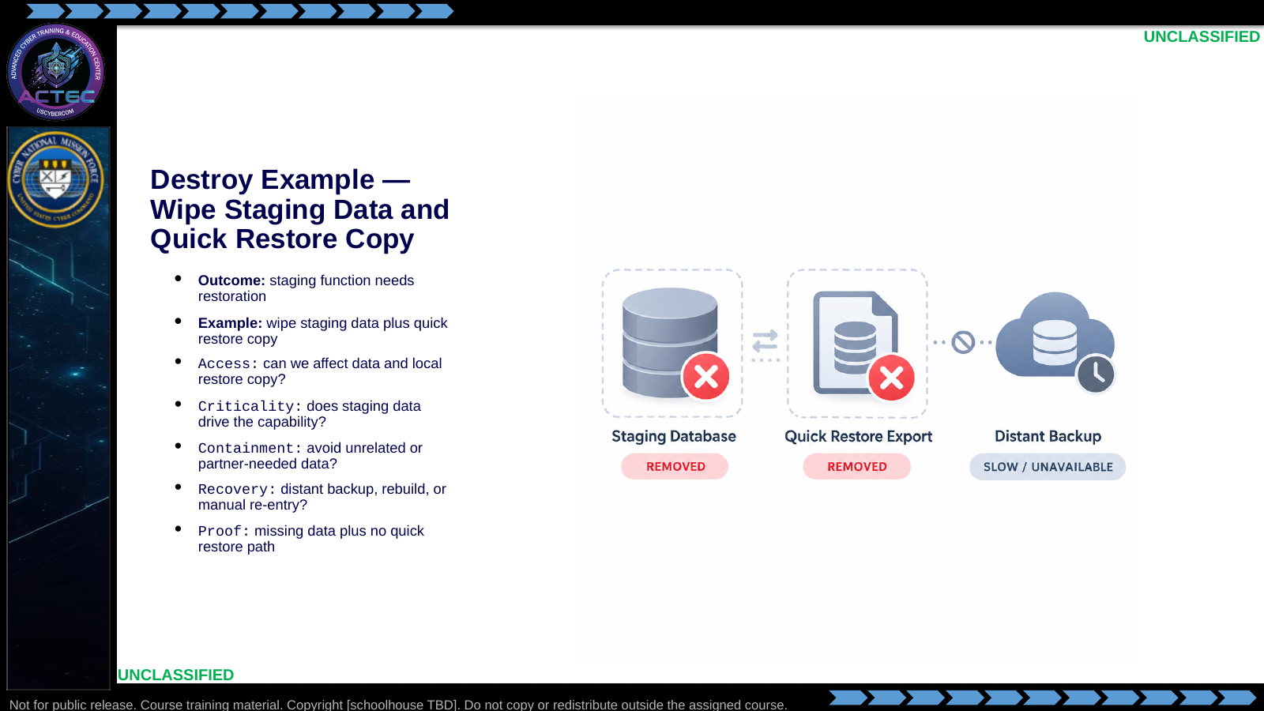  Slide 11: Destroy Example — Wipe Staging Data and Quick Restore Copy  Duration: 3 min | Say: - "This destroys by increasing recovery burden."  - "The live data alone may not be enough."  - "The quick restore copy matters."  - "Scenario: staging data feeds the adversary's analytic or reporting backend."  - "A nearby export or snapshot lets them restore quickly if only live data is lost."  - "Action: remove the staging data and the quick local restore copy in the same operation."  - "Students must avoid unrelated data and partner equities."  - "Criticality has to be tied to the adversary capability."  - "Evidence is missing staging data plus no quick local restore."  - "If ordinary admin steps restore it in minutes, it was not destroy."  Show: - Point to live staging data.  - Point to the quick restore copy.  - Point to the slower recovery path.  Do: - Ask: "Why does the nearby restore copy matter?"  - Ask: "What second-order effects must be checked?"  Ask (Q): Why does the nearby restore copy matter?  Expected Response (A): Facilitation. Use the Say/Do already on this row; do not force a single keyed answer.
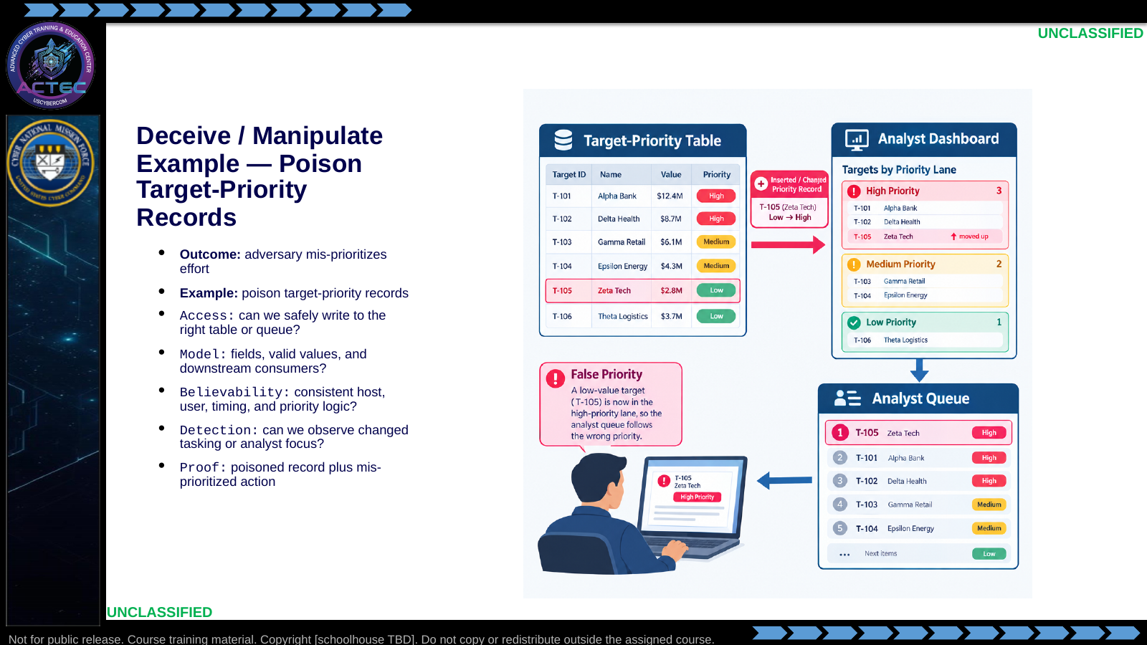  Slide 12: Deceive / Manipulate Example — Poison Target-Priority Records  Duration: 3 min | Say: - "Deception succeeds when the adversary chooses wrong for a believable reason."  - "Scenario: an analyst dashboard ranks targets from a backend priority table."  - "Priority fields drive what operators investigate first."  - "Action: insert or alter a believable record so the wrong target rises in the queue."  - "The goal is mis-prioritization, not outage."  - "Check the data model before writing anything."  - "Evidence is the poisoned record plus changed analyst focus."  Show: - Point to the priority record.  - Point to the dashboard queue.  - Point to the wrong high-priority target.  Do: - Ask: "What makes a false priority believable?"  - Steer toward field consistency, timing, and existing patterns.  Ask (Q): What makes a false priority believable?  Expected Response (A): field consistency, timing, and existing patterns
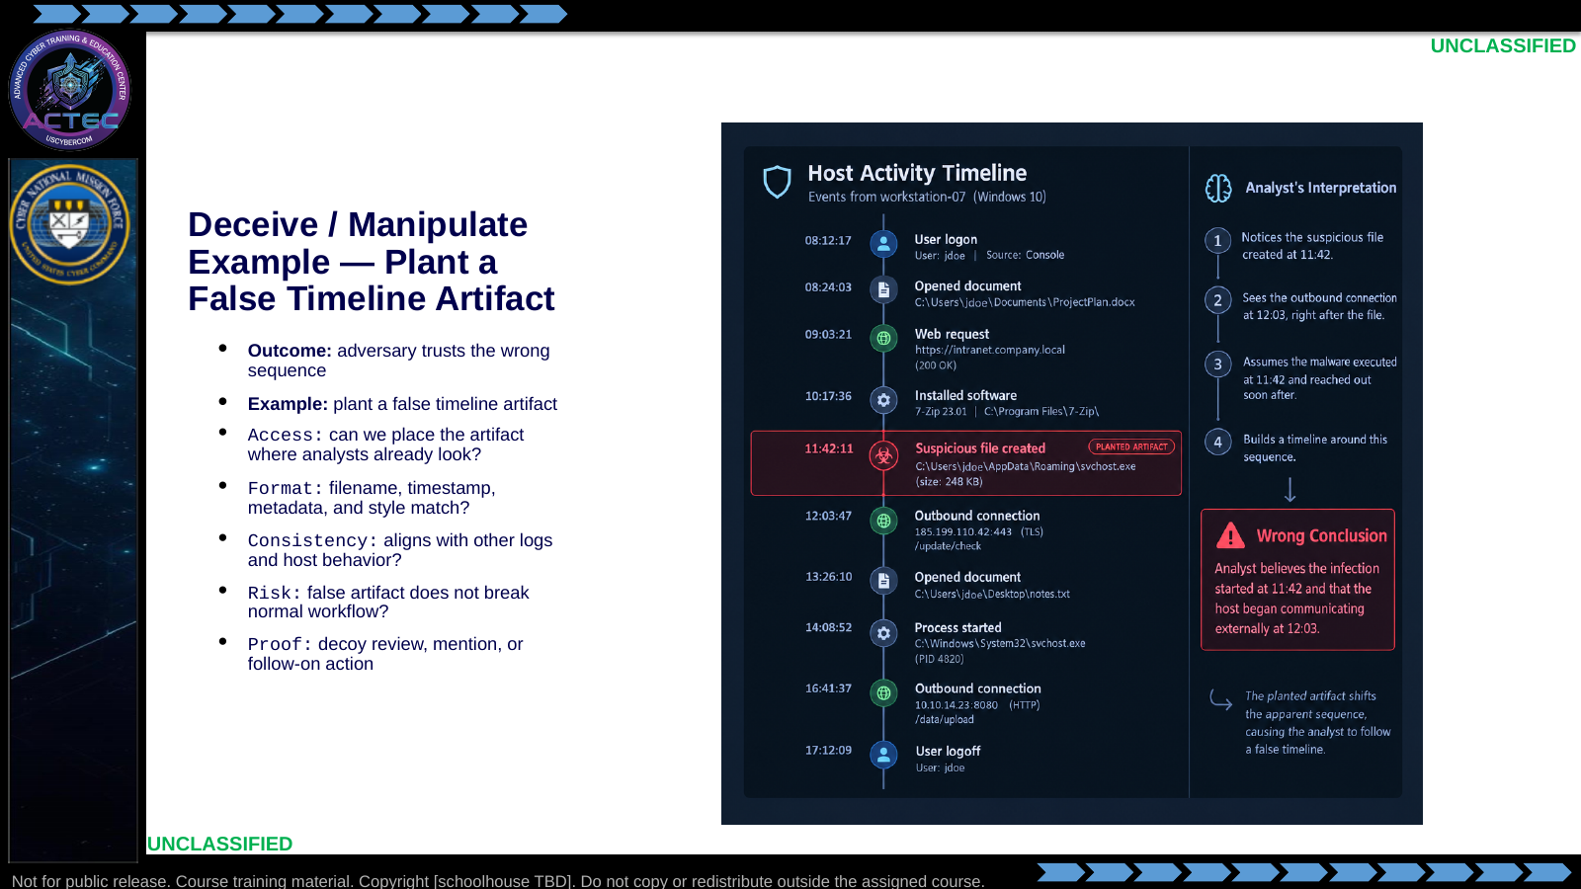  Slide 13: Deceive / Manipulate Example — Plant a False Timeline Artifact  Duration: 3 min | Say: - "This example manipulates the adversary's sense of sequence."  - "Scenario: analysts review documents, screenshots, or logs to reconstruct activity."  - "They trust artifacts that match normal naming, timing, and metadata."  - "Action: place a false timeline artifact in a location they already use."  - "The artifact must fit the environment around it."  - "If it looks staged, it fails."  - "Evidence is decoy review, mention, or follow-on action."  Show: - Point to authentic timeline entries.  - Point to the planted artifact.  - Point to the wrong conclusion.  Do: - Ask: "What would make this artifact stand out as fake?"  - Take two answers.  Ask (Q): What would make this artifact stand out as fake?  Expected Response (A): Facilitation. Use the Say/Do already on this row; do not force a single keyed answer.
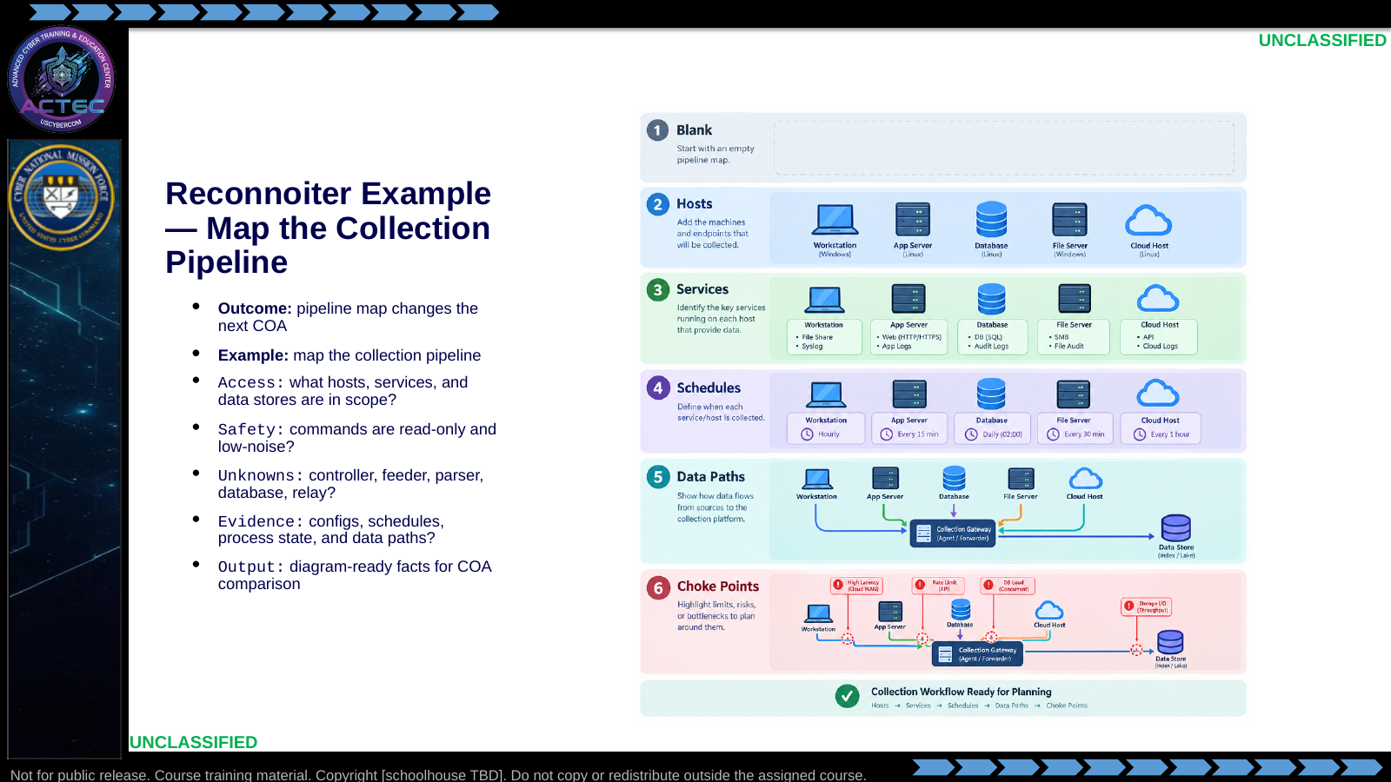  Slide 14: Reconnoiter Example — Map the Collection Pipeline  Duration: 3 min | Say: - "Reconnoiter is an effect when it answers a mission gap."  - "Scenario: the team has access but does not know how collection actually flows."  - "The pipeline may include feeders, parser jobs, staging storage, and reporting relays."  - "Action: enumerate services, schedules, configs, data paths, and process state."  - "The result should support COA comparison."  - "Use read-only, low-noise collection first."  - "Evidence is a pipeline map tied to real artifacts."  Show: - Build the map layer by layer.  - Point to newly discovered dependencies.  - Point to the likely choke point.  Do: - Ask: "What fact would change your next COA?"  - Take one or two answers.  Ask (Q): What fact would change your next COA?  Expected Response (A): Facilitation. Use the Say/Do already on this row; do not force a single keyed answer.
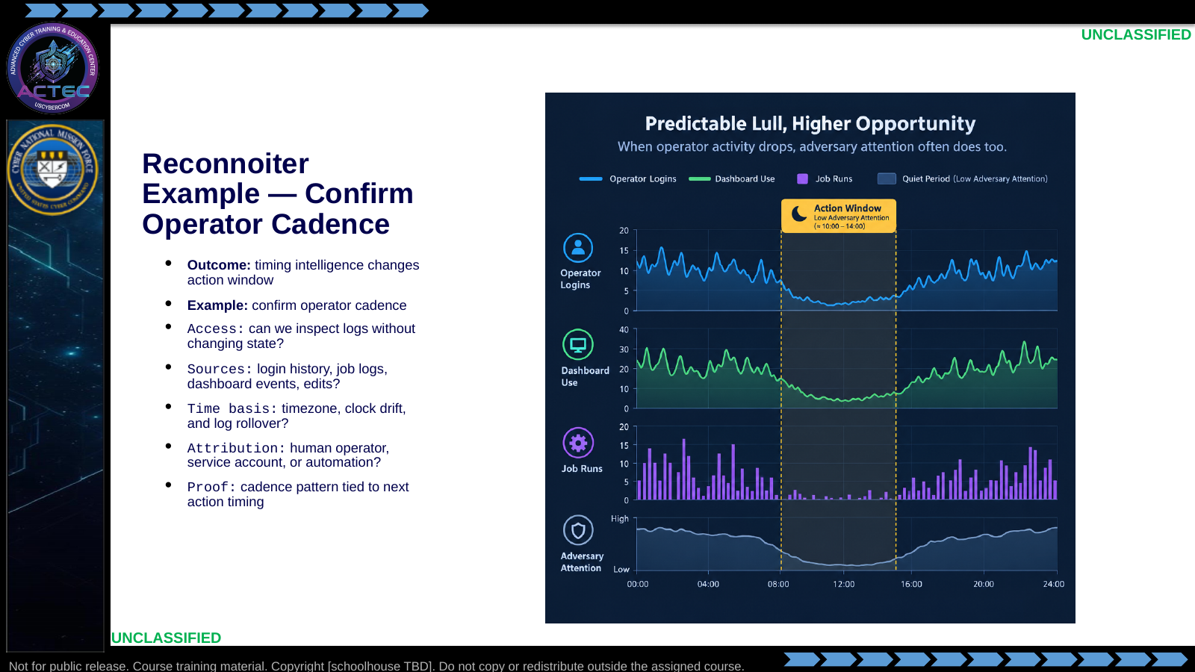  Slide 15: Reconnoiter Example — Confirm Operator Cadence  Duration: 3 min | Say: - "This recon example is about timing."  - "Scenario: stronger effects depend on when adversary operators are active or absent."  - "Logs may show login patterns, dashboard touches, task edits, or review cycles."  - "Action: compare multiple time sources to establish operator cadence."  - "Do not trust one timestamp without checking time basis."  - "Separate human activity from automation."  - "Evidence is a cadence pattern that changes when you act."  Show: - Point to active periods.  - Point to quiet periods.  - Point to the proposed action window.  Do: - Ask: "Why is timezone or clock drift a mission issue here?"  - Ask: "What source would corroborate operator activity?"  Ask (Q): Why is timezone or clock drift a mission issue here?  Expected Response (A): Facilitation. Use the Say/Do already on this row; do not force a single keyed answer.
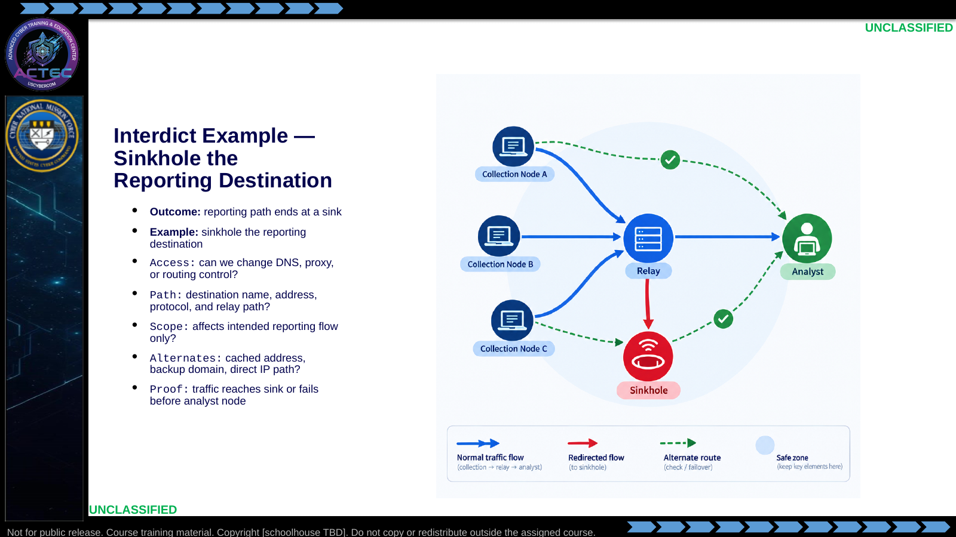  Slide 16: Interdict Example — Sinkhole the Reporting Destination  Duration: 3 min | Say: - "Interdict is pathway language."  - "Scenario: collected data reaches analysts through a named reporting destination."  - "The destination depends on DNS, proxy, or route resolution."  - "Action: sinkhole or redirect that destination so reporting never reaches the analyst node."  - "The endpoint tool may still run."  - "The path no longer delivers useful movement."  - "Evidence is sinkhole traffic or failed delivery before the analyst node."  Show: - Trace normal reporting path.  - Point to the sinkhole point.  - Point to alternate-route checks.  Do: - Ask: "Why is this interdict instead of local denial?"  - Make students answer in pathway terms.  Ask (Q): Why is this interdict instead of local denial?  Expected Response (A): Facilitation. Use the Say/Do already on this row; do not force a single keyed answer.
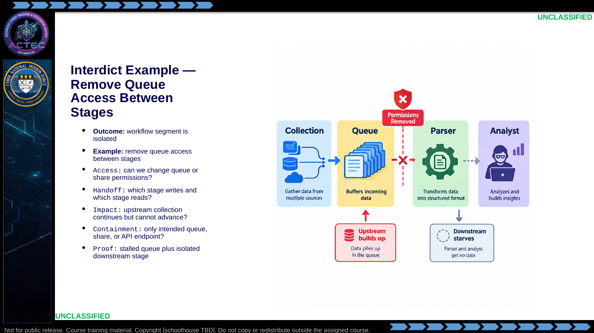  Slide 17: Interdict Example — Remove Queue Access Between Stages  Duration: 3 min | Say: - "This interdicts the handoff point."  - "Scenario: one stage drops data into a queue, share, or API endpoint."  - "A downstream stage reads from that handoff point and continues processing."  - "Action: remove or narrow access so the downstream stage cannot receive the handoff."  - "Upstream collection may still run."  - "The pathway between stages is cut."  - "Evidence is stalled queue growth and downstream starvation."  Show: - Point to upstream collection.  - Point to the handoff queue.  - Point to isolated downstream stage.  Do: - Ask: "What must students prove before changing permissions?"  - Ask: "What would show endpoint failure instead of pathway interdiction?"  Ask (Q): What must students prove before changing permissions?  Expected Response (A): Facilitation. Use the Say/Do already on this row; do not force a single keyed answer.
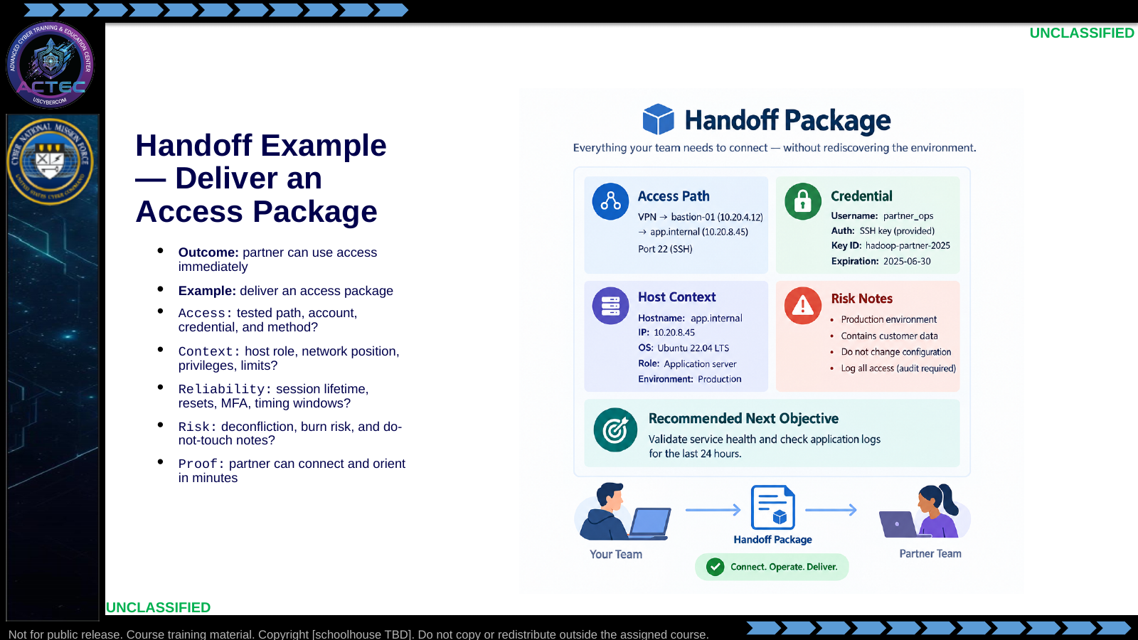  Slide 18: Handoff Example — Deliver an Access Package  Duration: 3 min | Say: - "Handoff's outcome is partner reach."  - "Scenario: your team has tactical access that another team needs to continue the mission."  - "The partner cannot afford to rediscover the environment."  - "Action: deliver a concise access package with connection method, credential, host context, limits, and risk notes."  - "The package must be usable in the first few minutes."  - "Include what not to touch."  - "Evidence is the partner connecting and orienting from your report."  Show: - Walk the package fields.  - Point to first-five-minutes usability.  - Point to risk notes.  Do: - Ask: "What would make this package unusable?"  - Build a short list live.  Ask (Q): What would make this package unusable?  Expected Response (A): Facilitation. Use the Say/Do already on this row; do not force a single keyed answer.
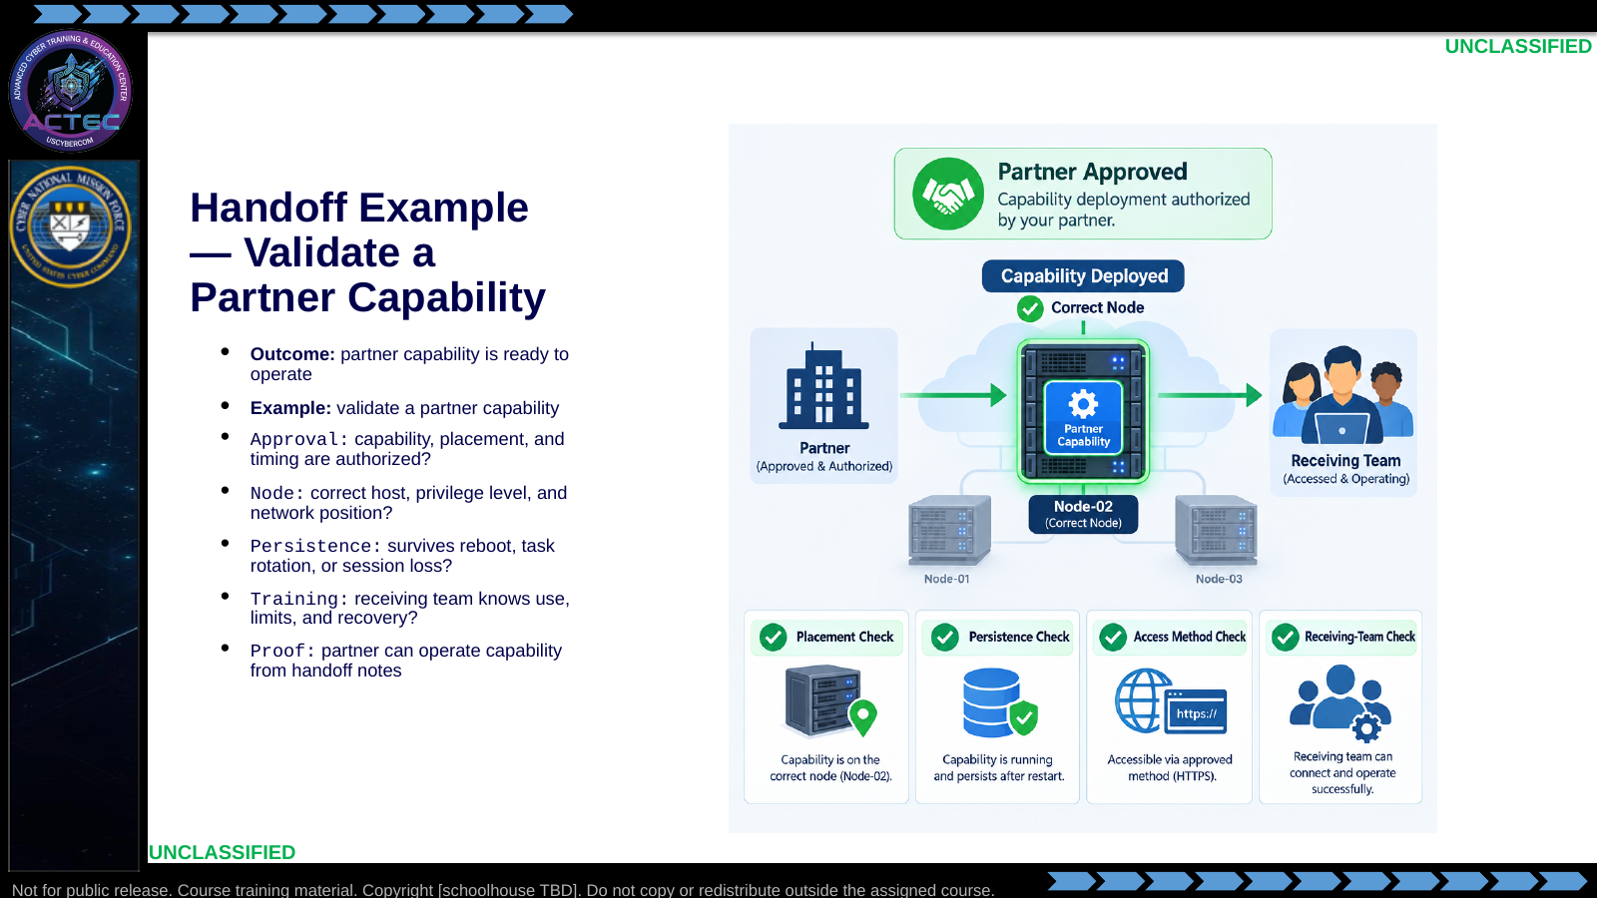  Slide 19: Handoff Example — Validate a Partner Capability  Duration: 3 min | Say: - "This handoff is more than reporting access."  - "Scenario: a partner-approved capability must be placed or validated on the right node."  - "The partner needs confidence that it works and will still be there when they take over."  - "Action: validate placement, access method, persistence behavior, and operating notes."  - "Do not improvise unapproved tools."  - "Training and limits are part of the handoff."  - "Evidence is the partner operating from your notes without rediscovery."  Show: - Point to the placement node.  - Point to persistence checks.  - Point to partner operating notes.  Do: - Ask: "What must be validated before the partner accepts this?"  - Ask: "What would burn the handoff?"  Ask (Q): What must be validated before the partner accepts this?  Expected Response (A): Facilitation. Use the Say/Do already on this row; do not force a single keyed answer.
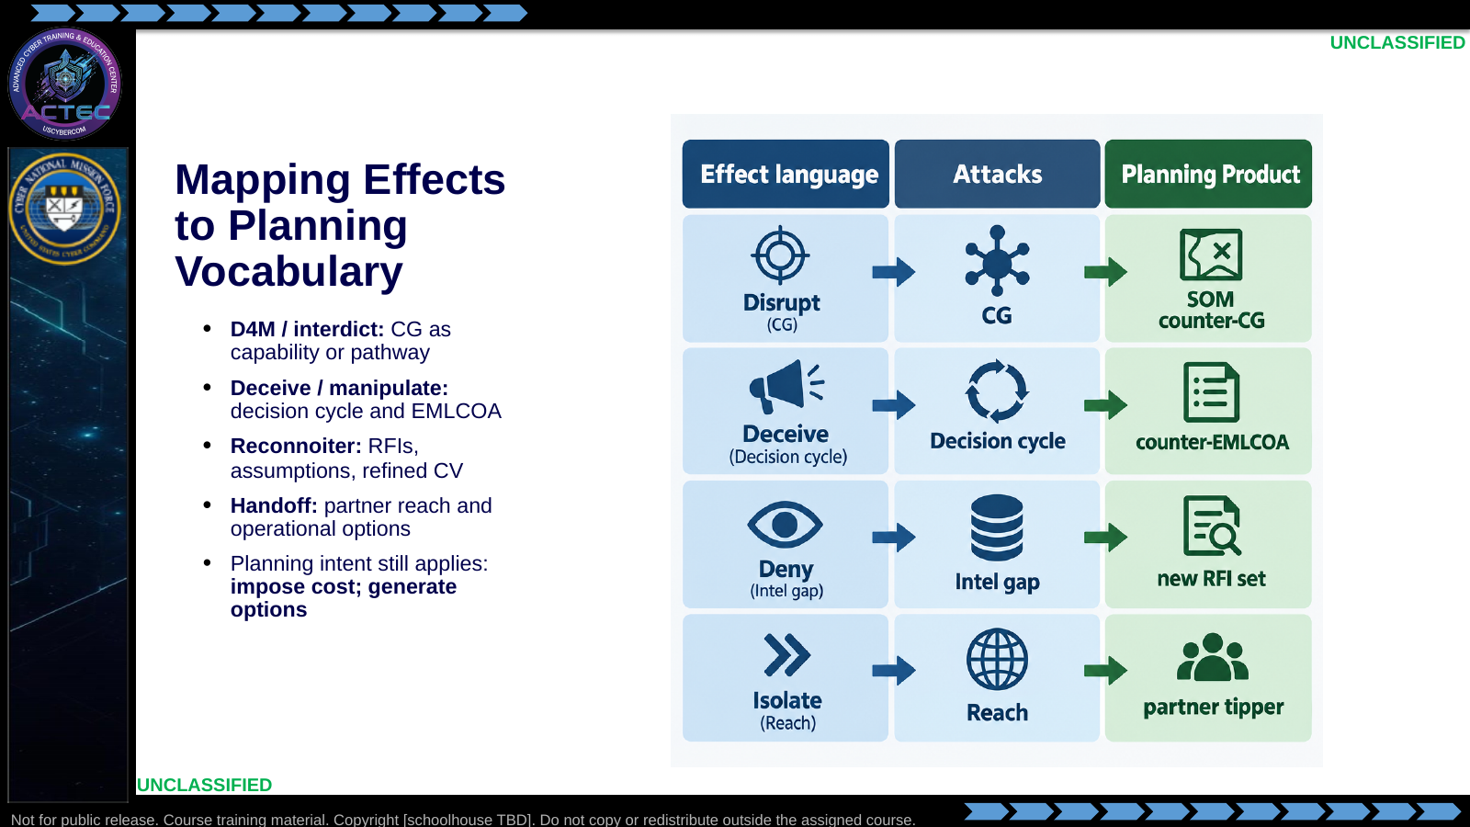  Slide 20: Mapping Effects to Planning Vocabulary  Duration: 3 min | Say: - "This is how you justify the effect."  - "D4M and interdict often attack CG as capability or pathway."  - "Deceive and manipulate attack decision cycle and EMLCOA."  - "Reconnoiter closes intelligence gaps and refines the next COA."  - "Handoff converts tactical success into operational reach."  - "Your answer to the commander should sound like tactical planning."  - "Every effect decision is a planning decision."  Show: - Walk the four lanes left to right.  - Tie each effect family to its planning product.  Do: - Return to the APT example from Slide 1.  - Assign one effect family to each student pair.  - Give two minutes for planning justification.  - Take one example back.  Ask (Q): What is the operational takeaway from this row?  Expected Response (A): Facilitation. Restate the Say/Do in operator terms. Do not invent a new teaching point.
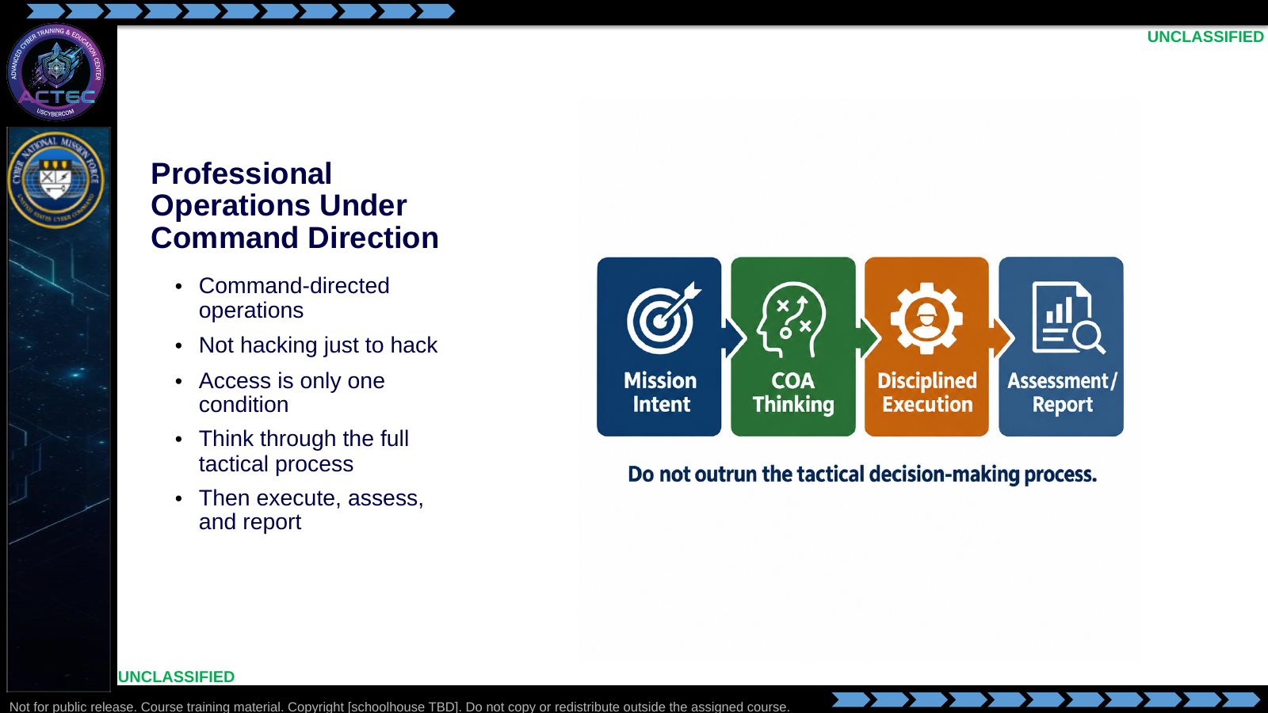  Slide 21: Professional Operations Under Command Direction  Duration: 3 min | Say: - "This course does not teach random hacking."  - "It trains command-directed effects operations."  - "Access is only one condition for action."  - "Reachability is not permission to start typing."  - "First: restate mission, desired effect, candidate actions, adversary response, team coordination, and success evidence."  - "Then: execute."  - "This is the bridge to the tactical decision-making process."  Show: - Point to "Mission Intent."  - Point to "COA Thinking."  - Point to "Disciplined Execution."  - Emphasize thinking before execution.  Do: - Ask: "What is the risk of hacking first and planning afterward?"  - Take two answers.  - Steer toward wrong effect, burned access, poor deconfliction, and unusable reporting.  Ask (Q): What is the risk of hacking first and planning afterward?  Expected Response (A): wrong effect, burned access, poor deconfliction, and unusable reporting
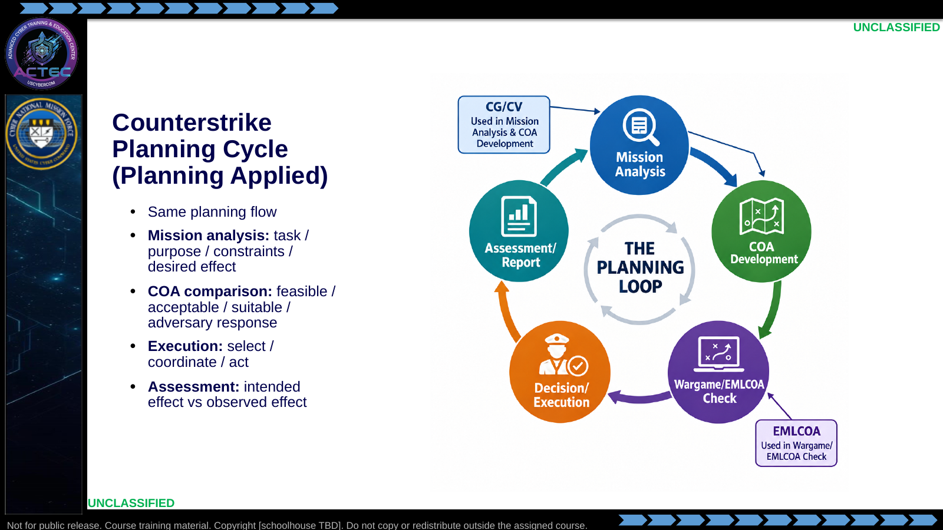  Slide 22: Counterstrike Planning Cycle (Planning Applied)  Duration: 3 min | Say: - "Apply planning discipline to every keyboard action."  - "First: define mission and desired effect."  - "Then: build and compare COAs."  - "Include likely adversary response."  - "Select and coordinate one COA."  - "Execute, assess intended versus observed effect, and report in commander language."  - "The technical command is the last step, not the first."  Show: - Walk the planning loop clockwise.  - Tie each node to planning products.  Do: - Scenario: "Task: deny adversary collection for one reporting period."  - Students verbalize mission analysis, candidate COA, anticipated adversary response, and assessment criterion.  Ask (Q): What is the operational takeaway from this row?  Expected Response (A): Facilitation. Restate the Say/Do in operator terms. Do not invent a new teaching point.
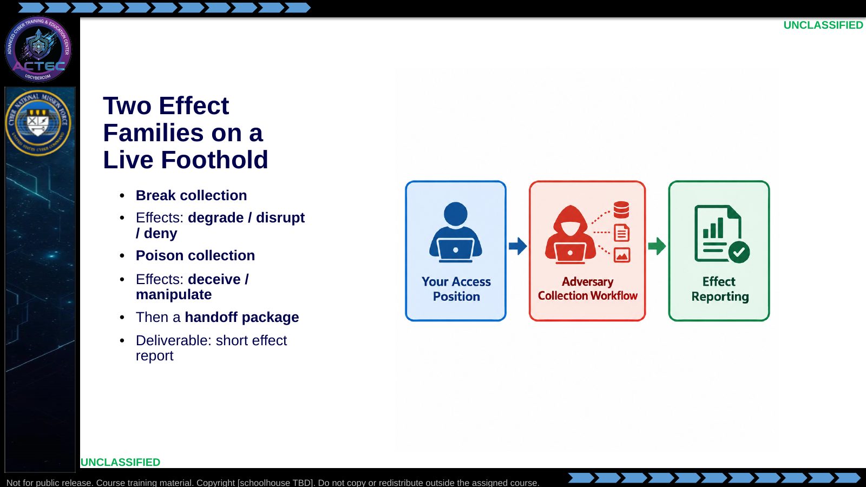  Slide 23: Two Effect Families on a Live Foothold  Duration: 3 min | Say: - "Two effect families on the same collection cell."  - "Same operational problem set."  - "Different effects."  - "Break collection: choose degrade, disrupt, or deny where reversible paths are preferred."  - "Poison collection: deceive or manipulate without producing an outage."  - "After those effects, the product is a handoff package another team can use."  - "Each practice produces a short effect report: effect, action, observed result, risk assessment."  - "Platform details live in the student briefs."  Show: - Show the generic operation flow.  - Keep attention on access, workflow, and reporting.  Do: - Hand out the break-collection student brief.  - Remind students the brief is the authority document.  - Break for 15 minutes, then begin the lab.  Ask (Q): What is the operational takeaway from this row?  Expected Response (A): Facilitation. Restate the Say/Do in operator terms. Do not invent a new teaching point.
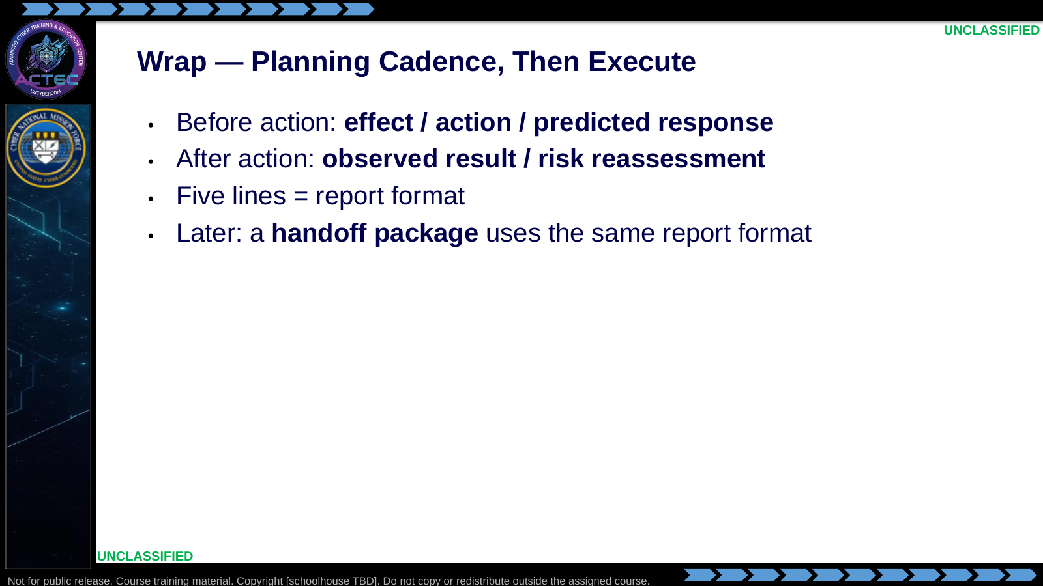  Slide 24: Wrap — Planning Cadence, Then Execute  Duration: 3 min | Say: - "Five lines."  - "Effect, action, predicted response, observed result, risk reassessment."  - "That is your report."  - "It is short on purpose; commanders read five lines."  - "First three lines happen before keyboard action."  - "Last two lines prove whether the intended effect occurred and whether risk changed."  - "If the action cannot survive five-line reporting, reconsider it."  Show: - Show the five-line cadence verbatim.  Do: - Students write the blank template in their notebook.  - They fill it in twice today and twice tomorrow.  - Release to break-collection practice.  Ask (Q): What is the operational takeaway from this row?  Expected Response (A): Facilitation. Restate the Say/Do in operator terms. Do not invent a new teaching point.

4.3 Lesson summary
- B04.M06-effects-operations-overview is executed as a generated lesson plan from this file.
- Assessment methods live on module.yaml; do not invent extra official ELOs.
- Later practice in this Block continues from the product this session collects.

4.4 Questions and check on learning
- Ask (Q): From planning, what is the center of gravity of the APT we studied?
- Expected Response (A): Facilitation. Use the Say/Do already on this row; do not force a single keyed answer.
- Ask (Q): Name an action you took on a prior on-target host.
- Expected Response (A): Facilitation. Use the Say/Do already on this row; do not force a single keyed answer.
- Ask (Q): What is the operational takeaway from this row?
- Expected Response (A): Facilitation. Restate the Say/Do in operator terms. Do not invent a new teaching point.

5. Classification
Classification: UNCLASSIFIED

